Hatch Warren Tigers Netball Club Ethos and Policies
2025-2026

- Ethos
- Player Code of Conduct
- Parent & Guardian Code of Conduct
- Player Appropriate Levels
- Dispute Resolution Procedure
- Keeping Staff Safe Policy
- Social Media Policy
- Social Media and Photography Policy
- Anti-Bullying Policy
- Safeguarding Policy
- Club Fee Term and Conditions

- Ethos

Hatch Warren Tigers (HWT) Netball Club has been formed with community at its centre. HWT is a club that is supported by and supports, local coaches and teachers to develop playing and leadership opportunities for young people in Basingstoke, and the wider community. Not only will we aim to support the development and performance of young people, but a focal point for our club will also be to develop the quality of netball opportunities for young people in our community, as well as supporting the development of new coaches and officials.

The Hatch Warren Tigers Community prides itself on being:

We expect our community to be kind, respectful and supportive to all both on and off the court.

- Player Code of Conduct

Hatch Warren Tigers Players Codes of Conduct require the highest standards of conduct from everyone involved in the club and netball to ensure that their behaviour and actions always meet the standards and values. Everyone must conduct themselves in an honest, fair and impartial manner.
As a player, I will respect
- The rules, regulations and requirements of the Sport, including, but not limited to, any competitions in which I participate either directly or indirectly.
- The rights, dignity and worth of all people involved in netball, regardless of gender, marital status, race, colour, disability, sexuality, age, occupation, religion or political opinion.
- The rights, dignity and worth of Children, Young People and Adults.
- Confidentiality and the sensitivities of information I hold on other individuals.
- Netball and the individual’s reputation and not take any action or make inappropriate comments about a fellow participant, coach, official, volunteer or member of England Netball’s staff that will bring the Sport or those associated with delivering the Sport into disrepute, including making comments on social media. I will respect EN’s guidance and policies on social media.
- The position I hold within Netball and always conduct and dress myself in an appropriate manner.
- The result of the game through direct or indirect involvement.

As a player I know netball is based on Teamwork, therefore I will:
- Not abuse or misuse any relationship of trust or position of power or influence held by me in my team, whether my playing team, Club, County, Regional or England Netball
- Be on time, dressed appropriately and ready to give my full attention to the role I am carrying out within Netball
- Recognise that individuals bring different qualities and attributes but “together we will excel”.
- Welcome new members, volunteers, and connected participants and cooperate with Members, Connected Participants, colleagues, coaches, officials already in the Sport
.
As a player, I recognise individuals participate in Netball to achieve and have fun, therefore I will:
- Recognise the achievements of others and applaud their successes
- Endeavour to ensure that all involved in the Sport optimise their potential by promoting the positive aspects of the sport and never condoning the use of inappropriate or abusive language, inappropriate relationships, bullying, harassment, discrimination or physical violence.
- Display modesty in victory and graciousness in defeat, be sporting - whether I win or lose.
- Always acknowledge the opposition and the umpires at the end of the game with a handshake or three cheers.
- Never argue with an official or participant during a game and listen to and cooperate with officials’ decisions.
- Control my emotions, I understand that verbal, emotional and physical abuse of officials, coaches, spectators or participants, or deliberately distracting or provoking a participant, coach or official is not acceptable or permitted behaviour.
- Enjoy the game and ensure others can also enjoy it.

As a player, I understand if I do not follow this code of conduct I may:
- Be required to apologise to a player, team, official or club member.
- Receive a formal warning from my coach or the Hatch Warren Tigers Committee
- Be suspended from training and matches.
- Be required to leave Hatch Warren Tigers.

- Parent & Guardian Code of Conduct

Hatch Warren Tigers has Codes of Conduct across the club driven by its core values of Respect, Commitment, Fairness, Encouragement and Support. Our codes require the highest standards of conduct from everyone involved in netball to ensure that their behaviour and actions meet the values and standards expected of them at all times. The enjoyment and safety of your child when they are involved in a netball activity is of paramount importance to England Netball. Every child will be encouraged and asked to ensure that their behaviour and actions meet the values and standards expected of them at all times. As parents and carers, you are also asked to support our Codes of Conduct and embrace the spirit of our game.
As a parent/carer I will:
- Encourage my child to play within the rules and respect official and coaching decisions and never argue.
- Support my child’s efforts and performance, give positive comments that motivate and
- Encourage continued effort and learning.
- Understand that competition is about winning and losing so results are always accepted without undue disappointment.
- Turn losing into winning by helping my child work towards skill improvement and good Sportsmanship.
- Remember that children learn best by example therefore I will applaud good plays by both my child’s team and their opponents.
- Thank the coaches, officials and other volunteers who give their time for my child.
- Help when asked by a coach or official where possible.
- Respect the rights, dignity and worth of all people involved in the game, regardless of gender, marital status, race, colour, disability, sexuality, age, occupation, religion or political opinion.
- Read the rules of the sport to understand better when watching and discussing netball with my child.
- Promote this code of conduct to other parents, carers and supporters

As a parent/carer I will not:
- Pressure my child in any way, knowing this is their sport, not mine.
- Use inappropriate language, harass athletes, Coaches, Officials or other spectators.
- Criticise or ridicule my child’s performance.
- Force my child to participate in the sport.
- Attend a netball activity under the influence of alcohol or drugs.
- Use social media to bring the game into disrepute or make an inappropriate comment about an athlete, coach, official, or volunteer.

As a parent/carer I understand if I do not follow this code of conduct I may:
- Be issued with a verbal warning from Hatch Warren Tigers or League Official.
- Be required to attend a meeting with members of Hatch Warren Tigers committee to discuss my conduct.
- Be required to leave the venue where the netball activity is being delivered.
- Be asked to not attend any future netball activity delivered by or with Hatch Warren Tigers in attendance.
- No longer continue to be a member of Hatch Warren Tigers Netball Club along with the child you are responsible for.

- Playing at the Appropriate Level: Age and Competition Guidelines

At Hatch Warren Tigers, the safety, well-being, and development of our players is at the heart of every decision we make. As part of our commitment to safeguarding and ethical practice, all decisions regarding the appropriate playing level, including age-group and competition placement, are made by the Head Coach, in collaboration with the club committee, relevant league chairs, and where appropriate, England Netball.

No player should be entered into any league, team, or competition outside of their designated age bracket or playing capabilities without prior consultation and approval from the Head Coach.

This policy is in place to:

- Protect individual players from entering environments that may not be developmentally or emotionally suitable;
- Safeguard other players and teams by ensuring compliance with welfare protocols when working with young people;
- Protect leagues and governing bodies from potential breaches of safeguarding policies and insurance liabilities in the case of injury or dispute.

Particular caution must be exercised with regards to adult league entries.

Procedure: Authorisation for Under-14 Players into Adult Leagues
This procedure applies to all Hatch Warren Tigers Netball Club players who are under 14 years of age as of 1st September of the current netball season.
Coach Assessment & Authorisation
- The player must be assessed and authorised to play in an Adult League by their Level 2 qualified coach.
- The assessment must confirm the player’s physical and mental readiness for adult competition.
Parental Consent
- Parents/guardians must provide written consent.
Notification & Record Keeping
- The Head Coach must be informed of the authorisation.
- The Club Secretary will notify the league via email, including the following details:
  - Player’s full name
  - Player’s age
  - Name of the authorising Level 2 coach
- A copy of the email will be retained on file by the club for reference.
Applicability Across Teams
- This procedure must be followed regardless of whether the player is representing Hatch Warren Tigers Netball Club or any other team/club in the league.
- Dispute Resolution Procedure

If a parent or guardian disagrees with a club/coaching decision, then the matter may be referred to the Disputes Resolution Committee for review. This committee will comprise the Safeguarding and Welfare Officer, Parent Rep and an independent third party who will consider the complaint/dispute and respond accordingly within a reasonable timescale. The outcome of this review may be a written response or a meeting involving all relevant parties to move the matter on or bring it to a close.

- Keeping Staff Safe Policy

Staff at HWT Netball club voluntarily work incredibly hard behind the scenes to support our young people and provide opportunities to play netball.

Any behaviour deemed to be threatening or abusive towards our staff or members will NOT be tolerated.

Behaviour of this kind will result in the player’s Immediate dismissal from the club without warning.

- Social Media Policy

Social Media – refers to all social networking sites such as (but not limited to):
Facebook, X Instagram, Tik Tok, Snapchat, Be Real, YouTube and covers any way these services are accessed. Hatch Warren Tigers Netball Club utilise various public social media platforms to celebrate success, provide opportunities’, provide updates, showcase our club and provide a centre for information. These pages will be closely monitored and run by the representatives of the Club Committee.
We will NEVER use any child’s full name or personal details or share their photo/video without parental permission which is given in the initial club registration form. Should photo permissions change these should be immediately to the Club Secretary at hwtigers@outlook.com. In the instance of ‘team photos’ being shared, players without consent will be removed or ‘blocked’ from the photo.
When using social media, members are expected to ensure that they:
- Respect the rights and confidentiality of others and the club
- Do not impersonate or falsely represent another person
- Do not bully, intimidate, abuse, harass or threaten others
- Do not make defamatory comments
- Do not use offensive, threatening or inappropriate language or resort to personal abuse towards each other or members of the Hatch Warren Tigers Community
- Do not post content that is hateful, threatening, illegal or incites violence against others
- Do not post content that harms the reputation and good standing of Hatch Warren Tigers or those within its community
- Adhere to the age restrictions for the use/membership of the social media site in question.
We advise against private player ‘WhatsApp’ or other messaging platforms groups being created outside the club’s supervision. Where possible, the use of SPOND should only be used to communicate.
- Social media and Photography
It is to be understood that parents and players MUST abide by the club’s social media and photography policy and agree to the following:
- Parents and Players will NEVER take photos or videos at training or fixtures without pre-arranged consent from the Head Coach
- If parents or players are caught filming or taking photos, the club reserves the right to ask for the photos/videos to be permanently deleted.
- Failure to adhere to this will result in removal from the session/fixture as well as a formal warning. Persistent failure will result in removal from the club
- Hatch Warren Tigers Netball Club will be responsible for all handling of images and footage, which will be shared on our social media with the right permissions.
We strongly recommend that players are not accessing their phones during training or fixtures unless by exceptional and prior agreement by the Coach.
Any member of the club who feels that they may have been subjected to any of the elements mentioned above for club related matters in regard to social media, should report such matters directly to the club via the Safeguarding and Welfare Officer. (Katie Allsopp – hwtsafeguarding@outlook.com)

- Anti-Bullying Policy

We are committed to providing a caring, friendly and safe environment for all our members so they can participate in sport in a relaxed and secure atmosphere.
Bullying of any kind is unacceptable in our club.
If bullying does occur, all club members should be able to tell and know that incidents will be dealt with promptly and effectively. We are a TELLING club. This means that anyone who knows that bullying is happening is expected to tell the Safeguarding and Welfare Officer.
What is Bullying?
Bullying is the use of aggression with the intention of hurting another person. Bullying results in pain and distress to the victim.
Bullying can be:
- Emotional - being unfriendly, excluding, tormenting (e.g. threatening gestures)
- Physical - pushing, kicking, hitting, punching or any use of violence racial taunts, graffiti, gestures
- Racial – comments both direct and indirect, regarding ethnicity or race
- Sexual - unwanted physical contact or sexually abusive comments
- Homophobic – comments both direct and indirect, regarding a person’s sexuality
- Verbal - name-calling, sarcasm, spreading rumours, teasing
- Cyber - All areas of internet, such as email & internet chat room misuse
Mobile threats by text messaging & calls
- Misuse of associated technology, i.e. camera & video facilities
The club has a responsibility to respond promptly and effectively to issues of bullying.
Procedures
- Report bullying incidents to the Safeguarding and Welfare Officer, member of the Club Committee or an adult you can trust (Katie Allsopp – hwtsafeguarding@outlook.com)
- In serious cases parents/guardians will be informed and invited to a meeting with the head coach
- If necessary and appropriate, police will be consulted
- The bullying behaviour or threats of bullying must be investigated, and the bullying stopped quickly
- If mediation fails and the bullying continues the club will initiate disciplinary proceedings according to the club constitution
Final Decisions will be made by the Head Coach and Committee.

- Safeguarding Policy

Hatch Warren Tigers Netball Club is committed to creating and maintaining a safe and positive environment for all young people to play netball. It accepts its responsibility to safeguard the welfare of all young people and protect them from poor practice, abuse and bullying.
It is vital that it is recognised that some children and young people may be more vulnerable than others of a similar age and that some regretfully may encounter extra barriers due to their race, gender, age, religion, disability, sexual orientation, social background and culture.
Hatch Warren Tigers Netball Club’s Safeguarding and Protecting Young People in Netball Policy and Procedures apply to all individuals involved, paid or in a voluntary capacity. Everyone has a responsibility.

Principles
Anyone under the age of 18 will be considered a child or young person in relation to Safeguarding and Protecting Young People in Netball Policy and Procedures. This also applies to coaches or umpires under the age of 18.
- The safety and welfare of all young people is paramount.
- All young people, regardless of age, ability, gender, race, religion, ethnic origin, social status or sexual orientation have the right to be protected from abuse.
- The rights, dignity and worth of all young people should always be respected.
- Al allegations, complaints of poor practice and alleged breaches of England Netball Codes of Conduct will be taken seriously and responded to quickly in line with the England Netball Policy and Procedures.
- It is the responsibility of safeguarding and child protection experts to determine whether or not abuse has taken place but it is everyone’s responsibility in netball to act appropriately and report concerns.
- Working in partnership with parents, carers and the young people themselves is essential for the safeguarding and protection of young people.

Roles and Responsibilities
Hatch Warren Tigers Netball Club have:-
1. Appointed a Club Safeguarding and Welfare Officer (in line with the England Netball Recruitment Guidelines and Volunteer Role Description to manage safeguarding and child protection. (Katie Allsopp – hwtsafeguarding@outlook.com)
2. Adopted and implemented the England Netball Safeguarding and Protecting Young People in Netball Policy and Procedures and Guidelines.
3. Ensured and will continue to ensure that all Committee members and club members are aware of their responsibility in Safeguarding and Protecting Young People in Netball.
4. Supported and will continue to support their members through accessing education and training opportunities in relation to the Safeguarding and Protecting Young People in Netball Policy.
5. Worked and will continue to work in partnership with parents/carers and young people within the club.
6. Ensured and will continue to ensure that all relevant members who have regular supervisory contact with young people are safely recruited according to EN guidelines which includes the completion of an Enhanced DBS check with England Netball.

Prohibited Practice and consequences of inappropriate action
Coaches, volunteers, umpires or managers must never:
- Spend time alone with young people away from others.
- Take young people to their home where they will be alone with them
- Invite or allow young people to stay with them at their home.
- Transport young people in your car alone.

If it should arise that such situations are unavoidable, they should only take place with the full knowledge and consent of someone in charge in the club/England Netball and/or a person with parental responsibility for the young person. In exceptional circumstances where a coach, manager or volunteer cannot obtain the consent of someone in charge in the Club/ England Netball and/or person with parental responsibility for the young person then if it is in the welfare interest of the young person, preceding paragraph does not have to be followed. If this occurs the adult must record the occurrence with the club/ England Netball CSO/EN Lead Child Protection Officer

- Engage in rough, physical or sexually provocative games with young people.
- Share a room with a young person unless the individual is the parent/guardian.
- Allow or engage in any form of inappropriate physical touching or sexual contact or behaviour.
- Use or allow young people to use inappropriate language unchallenged.
- Make sexually suggestive comments to a young person, even in fun.
- Allow allegations made by a young person to go unchallenged, unrecorded or not acted upon.
- Do things of a personal nature for young people that they can do for themselves, unless you have been requested to do so by the parents/carer. It is recognised that some young people will always need help with things such as lace tying, and it is also recognised that this does not preclude anyone attending to an injured/ill young person or rendering first aid.
- Depart the netball club or agreed rendezvous point until the safe dispersal of all young people is complete.
- Cause an individual to lose self-esteem by embarrassing, humiliating or undermining the individual.
- Treat some young people more favourably than others.
- Agree to meet a young person on their own on a one-to-one basis.

Procedure to follow if you are concerned that a young child is being abused and useful contacts 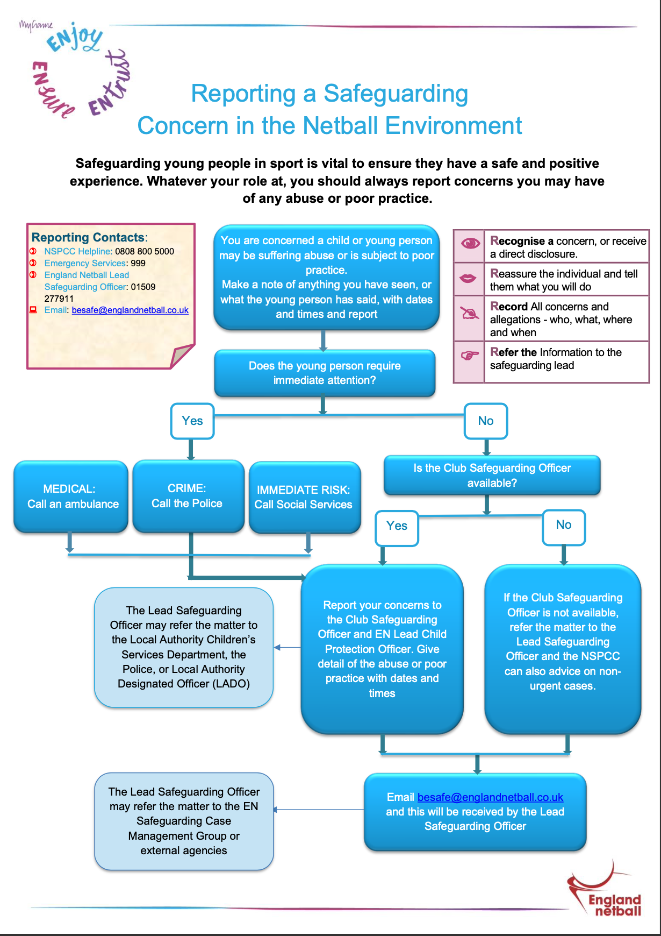

- Club Fee Terms and Conditions

- Club Fee Inclusions and Exclusions

Inclusions
- Weekly coaching with a qualified level 2 coach and level 1 assistant coach
- Court Hire
- Equipment Costs
- Personalised Nike Training T-Shirt (New Players Only)
- League Entrance Fees
- Match Fees for up to 4 tournaments
- Match Official SUBS

Exclusions
- England Netball Affiliation – to be paid directly to England Netball at the start of the 2025-2026 Season Deadline for this to be actioned will be 15th September
- Match kit e.g. dress

- Injury Policy
- Should your child sustain an injury (during HWT Netball training or matches) your monthly memberships fees will stop (free of charge) for the time they are unable to train. Annual fees will be frozen. Once your child can safely resume training and matches, the fees will re start 1st of the following month. Time lost on annual fees will be added to the start of the following season. Annual Fees will not be refunded unless agreed by the Club Committee. Decisions made by the Committee are final.

- Illness Policy
- Should your child miss a match or training session due to a short-term illness (less that 4 weeks) no refunds will be given.

- Should your child develop a medium-term illness (more than 4 weeks), any sessions missed due to a medium-term illness will be refunded at the end of the season or reduced from that season’s club fees.

- Should your child develop a long-term illness (more than 8 weeks) club fees will freeze or be cancelled free of charge, and any missed time refunded. Formal evidence of this should be submitted to the Head Coach, e.g Drs letters. No additional registration fees will be charged if your child decides to re-join HWT Netball club.

- Weather Policy
- Should training be cancelled due to unforeseen adverse weather, you will be notified by the Head Coach at least 1 hour in advance of your session. Any sessions cancelled by the Head Coach will be rescheduled later on in the season, where possible although we do factor this in to our training calendar.

- Registration Fees
- You will only be expected to pay registration fees once, as a new member unless membership is cancelled and re started.

- Cancellations
- Monthly payments can be cancelled at any time. Note – if your child decides to re-join, you will need to pay an additional £35 registration fee.
- No refunds will be given for annual cancellation, unless agreed by the Committee regarding section 2 & 3 (Injury & Illness policy)
- In the event that your child fails to attend 4 concurrent sessions (not due to illness or injury) the Committee may choose to cancel the players membership in order to free up a place for the waiting list.

- Late Payments
  - All monthly fees are due on 1st each month. We follow a 10 day grace period. If fees are not paid within 10 days, we will issue a payment reminders and requests on Spond. Failure to pay within 7 days of this request will result in a failure to pay notice. If you receive more than 2 failure to pay notices, a decision will be made regarding your child’s future attendance to the club.
  - Failure to make payment by the 10th of the month will incur a £6 late payment charge.
  - All annual fees are due 1st of the month after your child joins. We follow a 10-day grace period. If fees are not paid within 10 days, we will issue a reminder. Failure to pay within 7 days of the reminder will result in a failure to pay notice. If you receive more than 2 failure to pay notices, a decision will be made regarding your child’s future attendance to the club.
  - If you require an alternative payment date, please email hwtfinance@outlook.com
  - If you require financial support, please email hwtfinance@outlook.com

- Club Funded spaces

The Club will fund player spaces on the following basis:
- The player is a family member of a committee member or coach
- The player is a committee member or coach
- The player is awarded a scholarship recognising their improvement in netball

The decision to offer club funded spaces rests with the Club Chair and will be reviewed on an annual basis.

