Hatch Warren Tigers Netball Club Ethos and Policies
2024-2025

- Ethos
- Player Code of Conduct
- Parent & Guardian Code of Conduct
- Dispute Resolution Procedure
- Keeping Staff Safe Policy
- Social Media Policy
- Social Media and Photography Policy
- Anti-Bullying Policy
- Safeguarding Policy
- Club Fee Term and Conditions

- Ethos

Hatch Warren Tigers (HWT) Netball Club has been formed with community at its centre. HWT is a club that is supported by and supports, local coaches and teachers to develop playing and leadership opportunities for young people in Basingstoke, and the wider community. Not only will we aim to support the development and performance of young people, but a focal point for our club will also be to develop the quality of netball opportunities for young people in our community, as well as supporting the development of new coaches and officials.

The Hatch Warren Tigers Community prides itself on being:

We expect our community to be kind, respectful and supportive to all both on and off the court.

- Player Code of Conduct

HWT Netball club expects that players will:

- Be Respectful
- Play Fair
- Be Honest
- Be Kind
- Be Hardworking
- Be Supportive
- Be present and involved at training and fixtures
- Be gracious in defeat or victory
- Listen and respond to their coaches/officials
- Understand that a coach has to do what is best for the team and not one individual player
- Talk to someone I trust or the Club Safeguarding and Welfare Officer (Katie Allsop – hwtsafeguarding@outlook.com) if they are unhappy about anything at the club.

It is to be understood that if players continually refuse to follow the Players Code of Conduct, they could:
- Be required to apologise to team-mates, the other team, umpire or team manager
- Receive a formal warning from the coach or the Club Committee
- Be dropped or substituted
- Be suspended from training
- Be required to leave the club

Parents/Guardians will also be made aware of any persistent refusal to follow the Players Code of Conduct. Final decisions will be made by the Head Coach and Committee.

We aim to create not just a team of netball players, but a community of respectful and kind young people, by utilising sport as a tool to learn new skills, both on and off the court.

- Parent & Guardian Code of Conduct

HWT Netball club expects that parents and guardians:
- Remain Respectful
- Are Supportive
- Remember that young people play for FUN
- Respect official and coaches’ decisions
- Encourage young people to respect match and club officials
- Never engage in, or tolerate, offensive, insulting, or abusive language or
behaviour.

It is to be understood that if parents/guardians continually refuse to follow the Parents & Guardians Code of Conduct, they could be
- Issued with a verbal warning from the Club Committee or league official (Basingstoke Netball League)
- Required to meet with the Club Committee to discuss behaviour
- Obliged to leave the match venue by the club
- Requested by the club not to attend future games or training sessions
- Required to leave the club along with any siblings

Final Decisions will be made by the Head Coach and Committee.

- Dispute Resolution Procedure

If a parent or guardian disagrees with a club/coaching decision, then the matter may be referred to the Disputes Resolution Committee for review. This committee will comprise the Safeguarding and Welfare Officer, Parent Rep and an independent third party who will consider the complaint/dispute and respond accordingly within a reasonable timescale. The outcome of this review may be a written response or a meeting involving all relevant parties to move the matter on or bring it to a close.

- Keeping Staff Safe Policy

Staff at HWT Netball club voluntarily work incredibly hard behind the scenes to support our young people and provide opportunities to play netball.

Any behaviour deemed to be threatening or abusive towards our staff or members will NOT be tolerated.

Behaviour of this kind will result in the player’s Immediate dismissal from the club without warning.

- Social Media Policy

Social Media – refers to all social networking sites such as (but not limited to):
Facebook, X Instagram, Tik Tok, Snapchat, Be Real, YouTube and covers any way these services are accessed. Hatch Warren Tigers Netball Club utilise various public social media platforms to celebrate success, provide opportunities’, provide updates, showcase our club and provide a centre for information. These pages will be closely monitored and run by the representatives of the Club Committee.

We will NEVER use any child’s full name or personal details or share their photo/video without parental permission which is given in the initial club registration form. Should photo permissions change these should be immediately to the Club Secretary at hwtigers@outlook.com. In the instance of ‘team photos’ being shared, players without consent will be removed or ‘blocked’ from the photo.

When using social media, members are expected to ensure that they:
- Respect the rights and confidentiality of others and the club
- Do not impersonate or falsely represent another person
- Do not bully, intimidate, abuse, harass or threaten others
- Do not make defamatory comments
- Do not use offensive, threatening or inappropriate language or resort to personal abuse towards each other or members of the Hatch Warren Tigers Community
- Do not post content that is hateful, threatening, illegal or incites violence against others
- Do not post content that harms the reputation and good standing of Hatch Warren Tigers or those within its community
- Adhere to the age restrictions for the use/membership of the social media site in question.
We advise against private player ‘WhatsApp’ groups being created outside the club’s supervision.

- Social media and Photography

It is to be understood that parents and players MUST abide by the club’s social media and photography policy and agree to the following:

- Parents and Players will NEVER take photos or videos at training or fixtures without pre-arranged consent from the Head Coach
- If parents or players are caught filming or taking photos, the club reserves the right to ask for the photos/videos to be permanently deleted.
- Failure to adhere to this will result in removal from the session/fixture as well as a formal warning. Persistent failure will result in removal from the club
- Hatch Warren Tigers Netball Club will be responsible for all handling of images and footage, which will be shared on our social media with the right permissions.

We strongly recommend that players are not accessing their phones during training or fixtures unless by exceptional and prior agreement by the Coach.

Any member of the club who feels that they may have been subjected to any of the elements mentioned above for club related matters in regard to social media, should report such matters directly to the club via the Safeguarding and Welfare Officer. (Katie Allsop – hwtsafeguarding@outlook.com)

- Anti-Bullying Policy

We are committed to providing a caring, friendly and safe environment for all our members so they can participate in sport in a relaxed and secure atmosphere.
Bullying of any kind is unacceptable in our club.

If bullying does occur, all club members should be able to tell and know that incidents will be dealt with promptly and effectively. We are a TELLING club. This means that anyone who knows that bullying is happening is expected to tell the Safeguarding and Welfare Officer.

What is Bullying?
Bullying is the use of aggression with the intention of hurting another person. Bullying results in pain and distress to the victim.

Bullying can be:
- Emotional - being unfriendly, excluding, tormenting (e.g. threatening gestures)
- Physical - pushing, kicking, hitting, punching or any use of violence racial taunts, graffiti, gestures
- Racial – comments both direct and indirect, regarding ethnicity or race
- Sexual - unwanted physical contact or sexually abusive comments
- Homophobic – comments both direct and indirect, regarding a person’s sexuality
- Verbal - name-calling, sarcasm, spreading rumours, teasing
- Cyber - All areas of internet, such as email & internet chat room misuse
Mobile threats by text messaging & calls
- Misuse of associated technology, i.e. camera & video facilities

The club has a responsibility to respond promptly and effectively to issues of bullying.

Procedures
- Report bullying incidents to the Safeguarding and Welfare Officer, member of the Club Committee or an adult you can trust (Katie Allsop – hwtsafeguarding@outlook.com)
- In serious cases parents/guardians will be informed and invited to a meeting with the head coach
- If necessary and appropriate, police will be consulted
- The bullying behaviour or threats of bullying must be investigated, and the bullying stopped quickly
- If mediation fails and the bullying continues the club will initiate disciplinary proceedings according to the club constitution

Final Decisions will be made by the Head Coach and Committee.

- Safeguarding Policy

Hatch Warren Tigers Netball Club is committed to creating and maintaining a safe and positive environment for all young people to play netball. It accepts its responsibility to safeguard the welfare of all young people and protect them from poor practice, abuse and bullying.
It is vital that it is recognised that some children and young people may be more vulnerable than others of a similar age and that some regretfully may encounter extra barriers due to their race, gender, age, religion, disability, sexual orientation, social background and culture.
Hatch Warren Tigers Netball Club’s Safeguarding and Protecting Young People in Netball Policy and Procedures apply to all individuals involved, paid or in a voluntary capacity. Everyone has a responsibility.

Principles
Anyone under the age of 18 will be considered a child or young person in relation to Safeguarding and Protecting Young People in Netball Policy and Procedures. This also applies to coaches or umpires under the age of 18.

- The safety and welfare of all young people is paramount.
- All young people, regardless of age, ability, gender, race, religion, ethnic origin, social status or sexual orientation have the right to be protected from abuse.
- The rights, dignity and worth of all young people should always be respected.
- Al allegations, complaints of poor practice and alleged breaches of England Netball Codes of Conduct will be taken seriously and responded to quickly in line with the England Netball Policy and Procedures.
- It is the responsibility of safeguarding and child protection experts to determine whether or not abuse has taken place but it is everyone’s responsibility in netball to act appropriately and report concerns.
- Working in partnership with parents, carers and the young people themselves is essential for the safeguarding and protection of young people.

Roles and Responsibilities
Hatch Warren Tigers Netball Club have:-
1. Appointed a Club Safeguarding and Welfare Officer (in line with the England Netball Recruitment Guidelines and Volunteer Role Description to manage safeguarding and child protection. (Katie Allsop – hwtsafeguarding@outlook.com)
2. Adopted and implemented the England Netball Safeguarding and Protecting Young People in Netball Policy and Procedures and Guidelines.
3. Ensured and will continue to ensure that all Committee members and club members are aware of their responsibility in Safeguarding and Protecting Young People in Netball.
4. Supported and will continue to support their members through accessing education and training opportunities in relation to the Safeguarding and Protecting Young People in Netball Policy.
5. Worked and will continue to work in partnership with parents/carers and young people within the club.
6. Ensured and will continue to ensure that all relevant members who have regular supervisory contact with young people are safely recruited according to EN guidelines which includes the completion of an Enhanced DBS check with England Netball.

Prohibited Practice and consequences of inappropriate action

Coaches, volunteers, umpires or managers must never:
- Spend time alone with young people away from others.
- Take young people to their home where they will be alone with them
- Invite or allow young people to stay with them at their home.
- Transport young people in your car alone.

If it should arise that such situations are unavoidable, they should only take place with the full knowledge and consent of someone in charge in the club/England Netball and/or a person with parental responsibility for the young person. In exceptional circumstances where a coach, manager or volunteer cannot obtain the consent of someone in charge in the Club/ England Netball and/or person with parental responsibility for the young person then if it is in the welfare interest of the young person, preceding paragraph does not have to be followed. If this occurs the adult must record the occurrence with the club/ England Netball CSO/EN Lead Child Protection Officer

- Engage in rough, physical or sexually provocative games with young people.
- Share a room with a young person unless the individual is the parent/guardian.
- Allow or engage in any form of inappropriate physical touching or sexual contact or behaviour.
- Use or allow young people to use inappropriate language unchallenged.
- Make sexually suggestive comments to a young person, even in fun.
- Allow allegations made by a young person to go unchallenged, unrecorded or not acted upon.
- Do things of a personal nature for young people that they can do for themselves, unless you have been requested to do so by the parents/carer. It is recognised that some young people will always need help with things such as lace tying, and it is also recognised that this does not preclude anyone attending to an injured/ill young person or rendering first aid.
- Depart the netball club or agreed rendezvous point until the safe dispersal of all young people is complete.
- Cause an individual to lose self-esteem by embarrassing, humiliating or undermining the individual.
- Treat some young people more favourably than others.
- Agree to meet a young person on their own on a one-to-one basis.

Procedure to follow if you are concerned that a young child is being abused and useful contacts 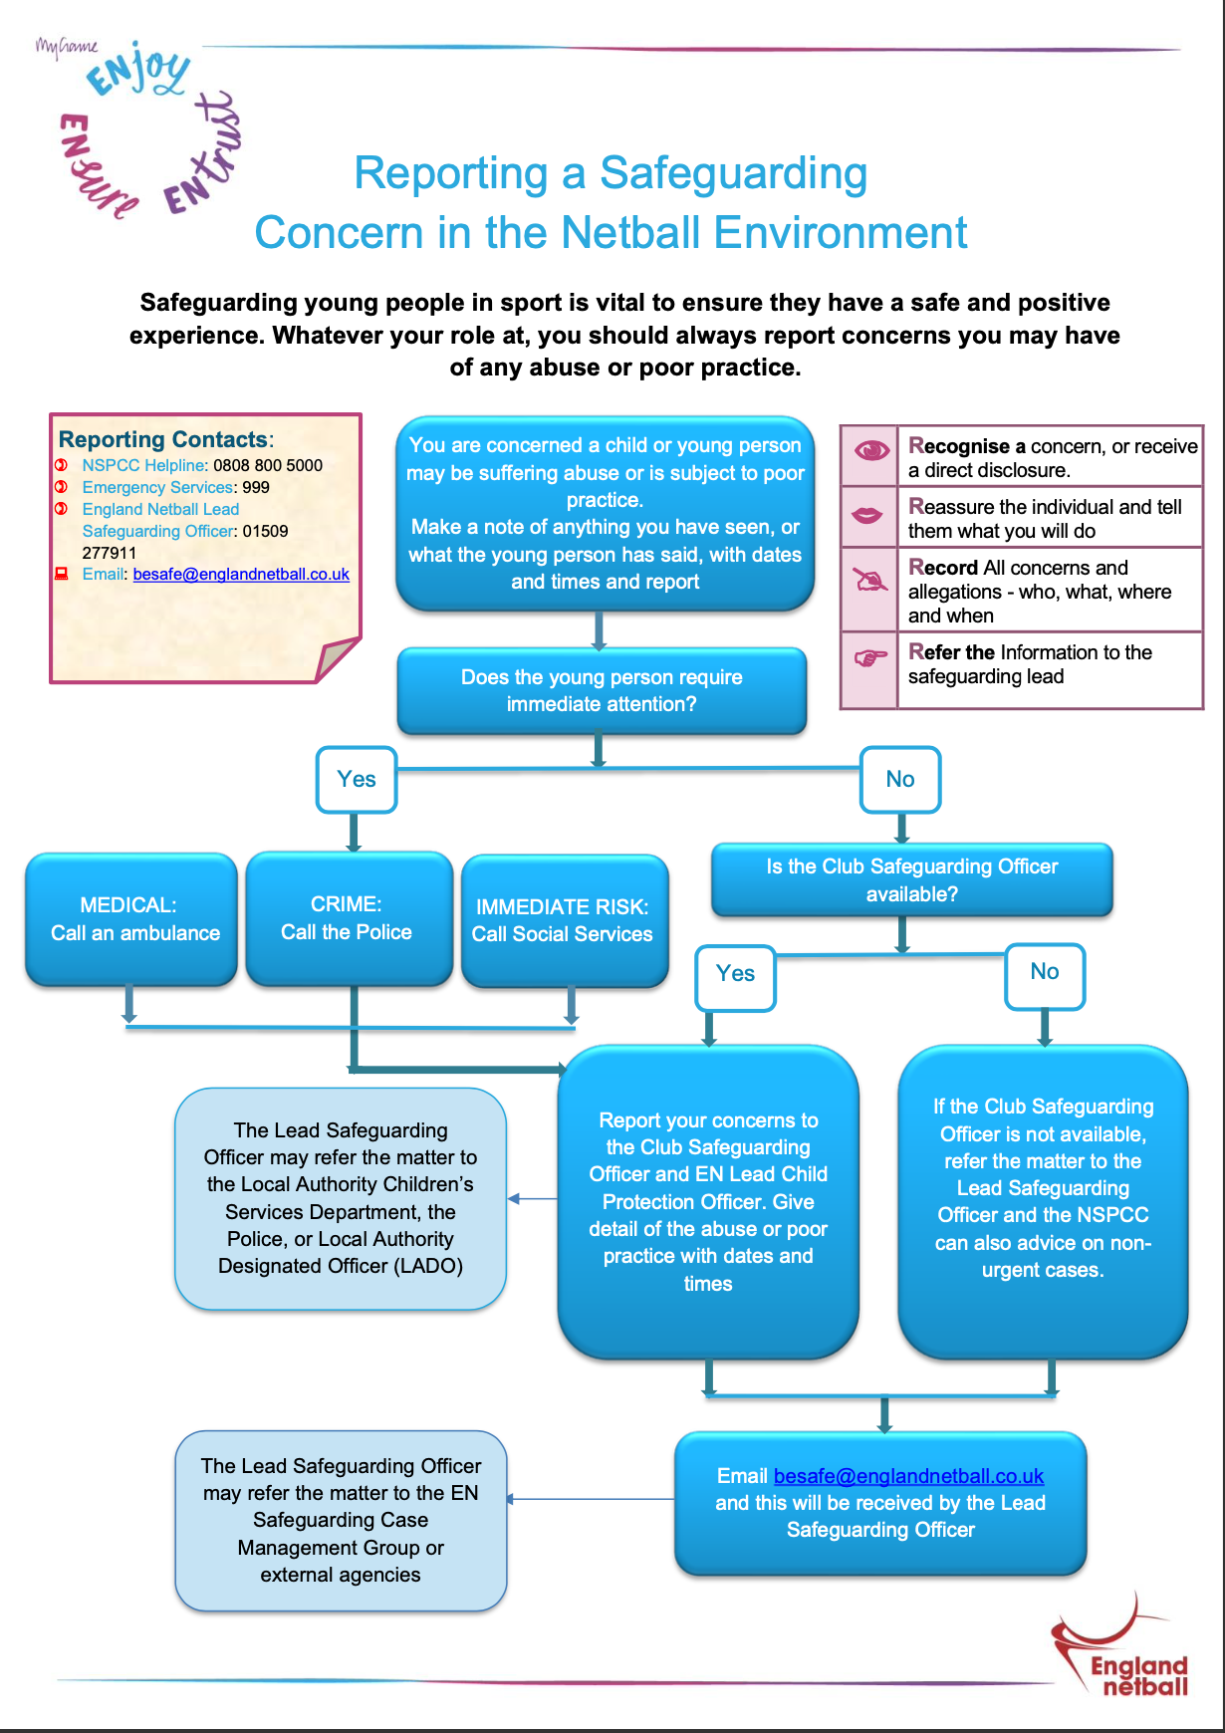

- Club Fee Terms and Conditions

- Club Fee Inclusions and Exclusions

Inclusions
- Weekly coaching with a qualified level 2 coach and level 1 assistant coach
- Court Hire
- Equipment Costs
- Personalised Nike Training T-Shirt (New Players Only)
- League Entrance Fees
- Match Fees for tournaments and friendlies (maximum of 3 for county and district)
- Match Fees for tournaments and friendlies (Minimum of 8 for developmental teams)
- Match Official SUBS

Exclusions
- England Netball Affiliation – to be paid directly to England Netball at the start of the 2024-2025season (U11 £5.30 U14 £8.55 U18 £16.30). Deadline for this to be actioned will be 15th September

- Injury Policy
- Should your child sustain an injury (during HWT Netball training or matches) your monthly memberships fees will stop (free of charge) for the time they are unable to train. Annual fees will be frozen. Once your child can safely resume training and matches, the fees will re start 1st of the following month. Time lost on annual fees will be added to the start of the following season. Annual Fees will not be refunded unless agreed by the Club Committee. Decisions made by the Committee are final.

- Illness Policy
- Should your child miss a match or training session due to a short-term illness (less that 4 weeks) no refunds will be given.

- Should your child develop a medium-term illness (more than 4 weeks), any sessions missed due to a medium-term illness will be refunded at the end of the season. Or reduced from that season’s club fees (e.g. x1 month missed = £20/£30 refunded or £20 /£30 off first payment of the following season)

- Should your child develop a long-term illness (more than 8 weeks) club fees will freeze or be cancelled free of charge, and any missed time refunded. Formal evidence of this should be submitted to the Head Coach, e.g Drs letter). No additional registration fees will be charged if your child decides to re-join HWT Netball club.

- Weather Policy
- Should training be cancelled due to unforeseen adverse weather, you will be notified by the Head Coach at least 1 hour in advance of your session. Any sessions cancelled by the Head Coach will be rescheduled later on in the season, where possible.

- Registration Fees
- You will only be expected to pay registration fees once, as a new member unless membership is cancelled and re started.

- Cancellations
- Monthly payments can be cancelled at any time. Note – if your child decides to re-join, you will need to pay an additional £25 registration fee.
- No refunds will be given for annual cancellation, unless agreed by the Committee regarding section 2 & 3 (Injury & Illness policy)
- In the event that your child fails to attend 4 concurrent sessions (not due to illness or injury) the Committee may choose to cancel the players membership in order to free up a place for the waiting list.

- Late Payments
  - All monthly fees are due on 1st each month. We follow a 7-day grace period. If fees are not paid withing 7 days, we will issue a reminder. Failure to pay within 7 days of the reminder will result in a failure to pay notice. If you receive more than 2 failure to pay notices, a decision will be made regarding your child’s future attendance to the club.
  - If you can provide us with sufficient notice, within 7 days of the 1st on late payments, we will NOT issue a failure to pay notice. Failure to make payment by the 14th of the month will incur a £5 charge added.
  - All annual fees are due 1st of the month after your child joins. We follow a 14-day grace period. If fees are not paid withing 14 days, we will issue a reminder. Failure to pay within 7 days of the reminder will result in a failure to pay notice. If you receive more than 2 failure to pay notices, a decision will be made regarding your child’s future attendance to the club.
  - If you require an alternative payment date, please email hwtfinance@outlook.com
  - If you require financial support, please email hwtfinance@outlook.com

- Club Funded spaces

The Club will fund player spaces on the following basis:
- The player is a family member of a committee member or coach
- The player is a committee member or coach
- The player is awarded a scholarship recognising their improvement in netball

The decision to offer club funded spaces rests with the Club Chair and will be reviewed on an annual basis.

